Z6

JULY 2012 [BELOW]

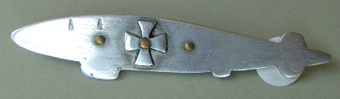
A typical local souvenir of L48

August 2012 [below]

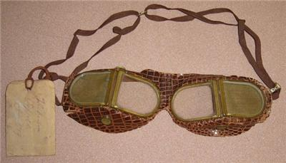

Goggles recovered from the wreck of L48

