ZEPPELIN L48 PHOTOS..PAGE 5

MAY 2011

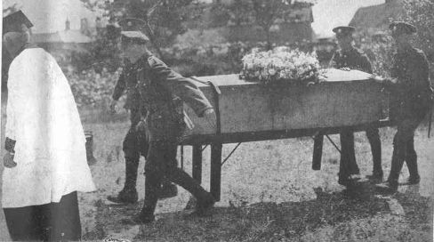

The funeral of Commander Eichler from L48..T.P.

June 2011 [below]

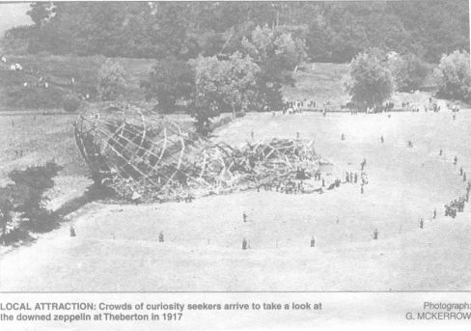

The best photo of the crash site…from Tony P.

August 2011 [below]

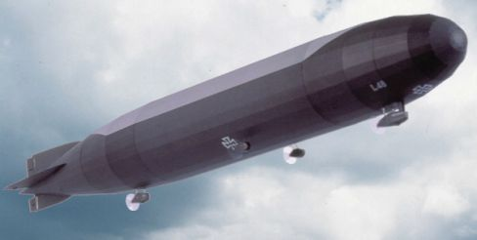

Card model of L48..you can still buy these online.

September 2011

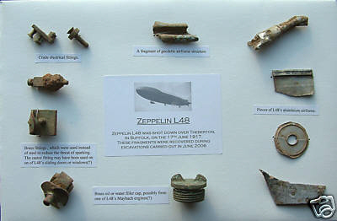

The few remains of L48 found by the Time Team

October 2011

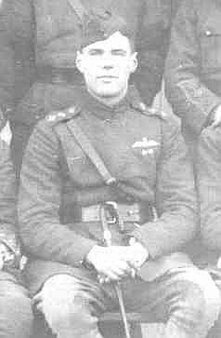

Gunner Holder who shot down L48….Tony Preston

November 2011 [below]

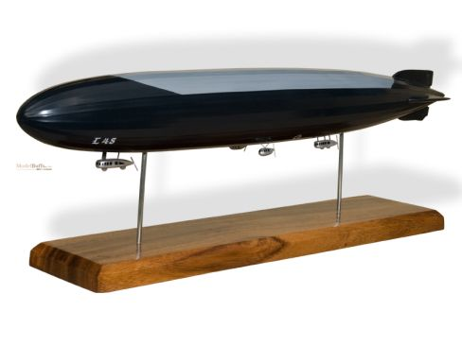

A model of the L48..you can buy these for about £100…T.P.

December 2011 [below]

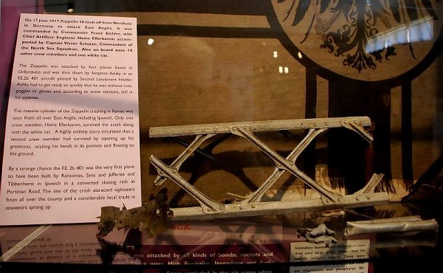

L48 remains in Ipswich Museum
Inaccurately labelled – 3 crewmen survived, but one died 18 months later on Armistice Day….T.P.

January 2012 [below]

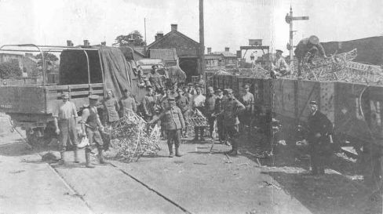

L48 bits at Leiston Station for shipping away….T.P.

February 2012 [below]

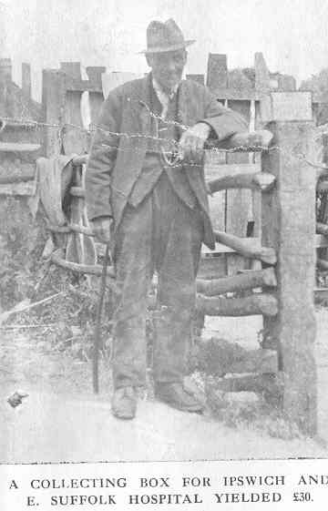

March 2012 [below]

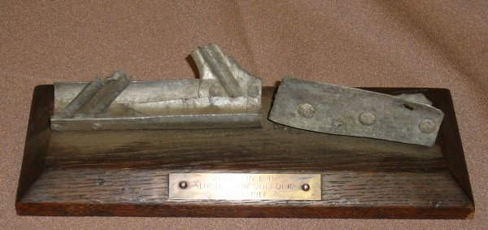

A typical L48 souvenir piece…T.P.

April 2012 [below]

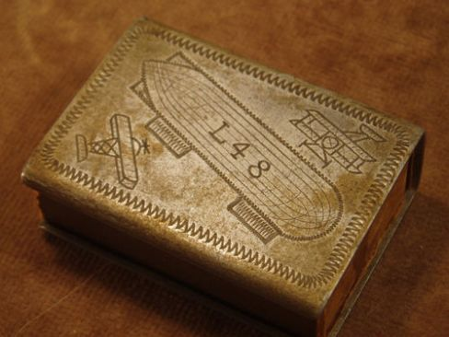
Matchbox cover of L48…T.P.

May 2012

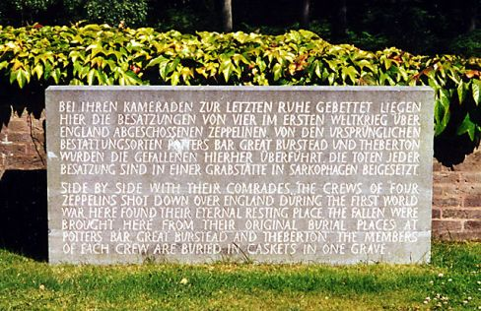

The Zeppelin crew graves plaque at Cannock Chase

June 2012 [below]
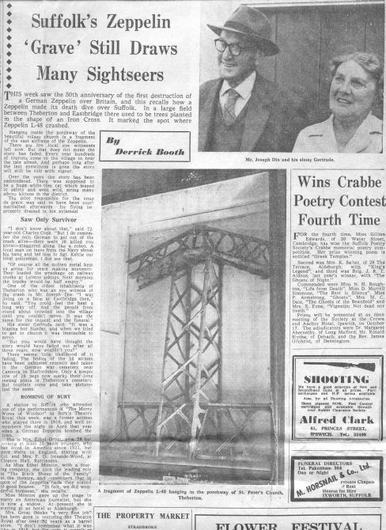
EADT 1967

