PHOTOS OF ZEPPELIN L 48 [PAGE 4]

MARCH 2010

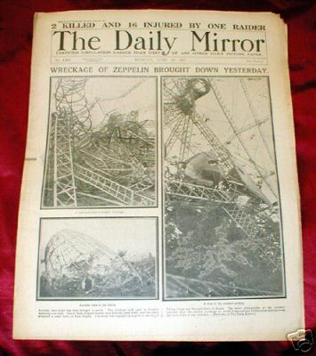

The headlines in the Daily Mirror
April 2010 [below]

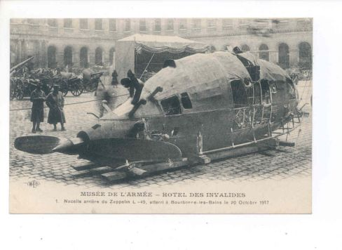
Rear engine nacelle of the L49 in Paris.
Identical to our L48….T.P.

May 2010

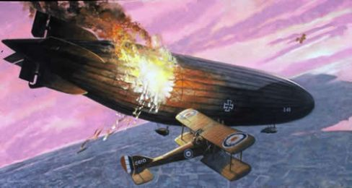

Watkins attacks the L48…from T.P.

June 2010 [below]

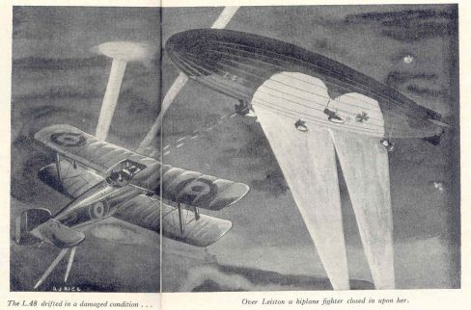
From the East Anglian magazine Sep. 1951…from T.P.

July 2010

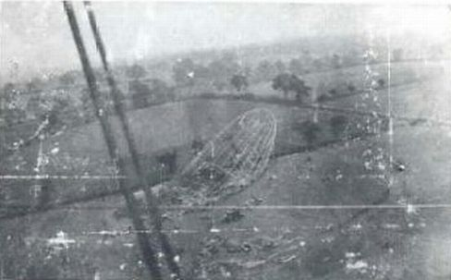

Aerial view of L48 via aircraft’s wing struts! …T.P.

August 2010 [below]

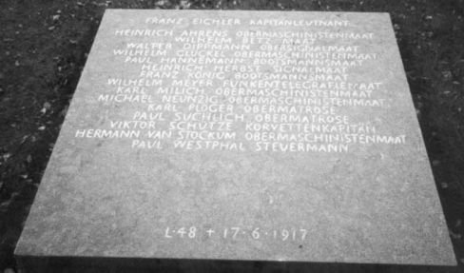

Memorial slab at Cannock Chase………….T.P/

September 2010 [below]

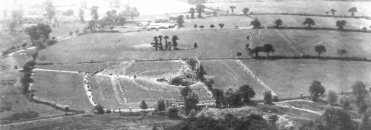

Aerial view of the crash site…T.P.

October 2010 [below]

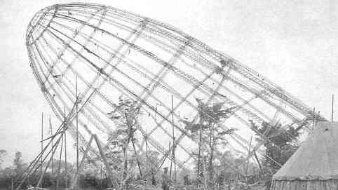

A rare shot of L48’s nose propped up……….T.P.

November 2010

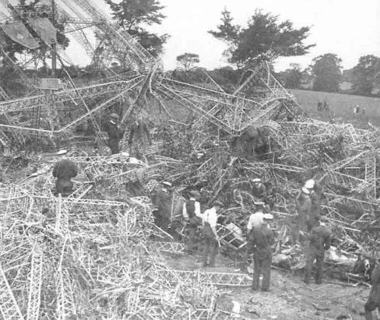

R.N.A.S. crew search the wreck of L48…..from T.P.

December 2010 [below]

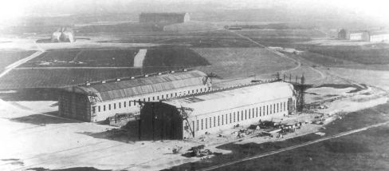

L48’s shed at Nordholtz..top far distance…from Tony P.

January 2011 [below]

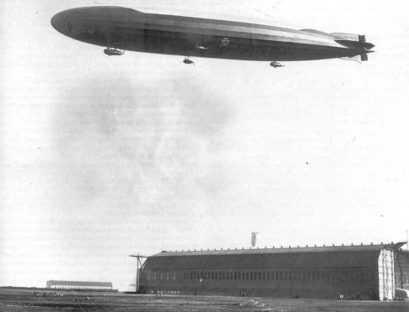

L48 flies over the Normann shed at Nordholtz…T.P.

Feb 2011 [below]

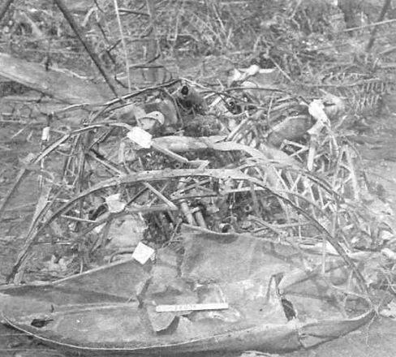

Crumpled gun gondola of L48….T.P

March 2011[below]

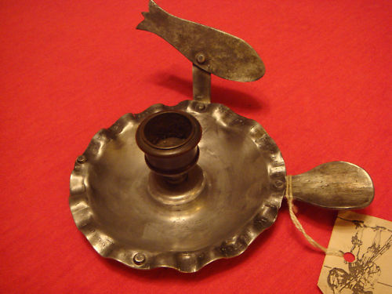

A nightstick made from wreckage of L48..
you could buy this on Ebay for £300 !!

April 2011 [below]

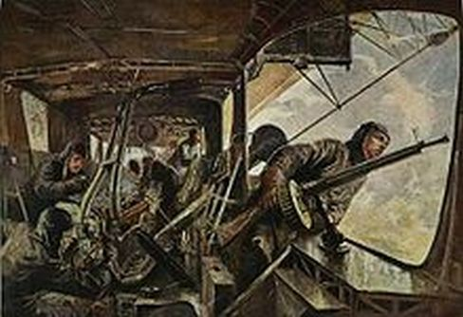

Inside a gun gondola like L48 in 1917

May 2011 [below]

