OLD PHOTOS OF ZEPPELIN L48 page 3

July 2009 [below]

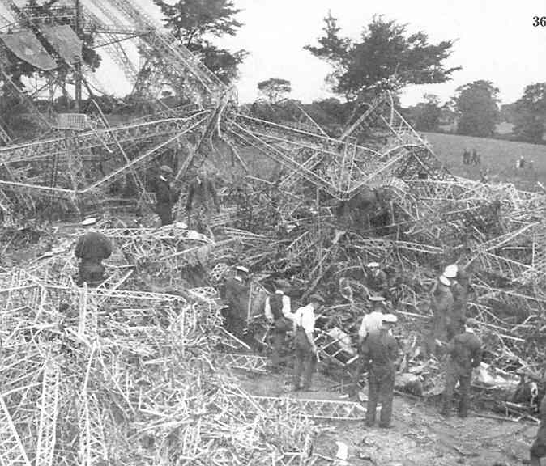

Members of the RNAS work on L48
[from Ray Rimmell’s book]

August 2009 [below]
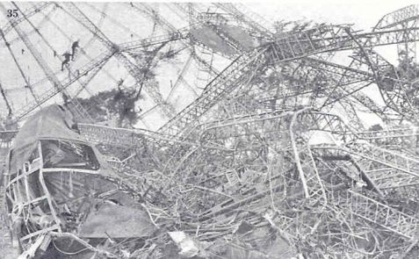
L48 Gondola…via T.P. from Ray Rimmell’s book

September 2009 [below]

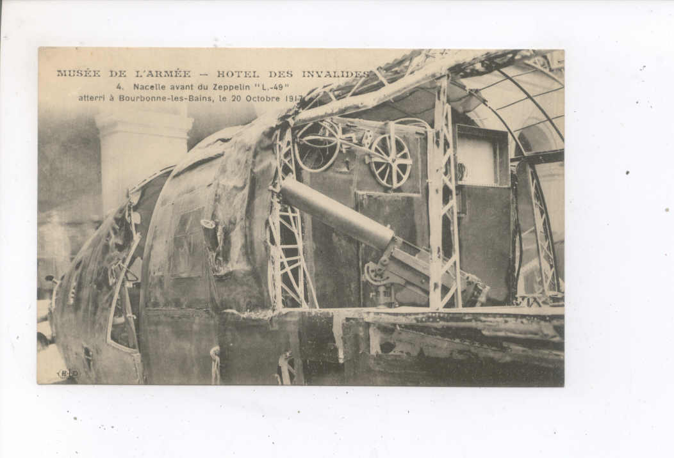
Inside the gun nacelle of L49..identical to L48..T.P.

October 2009 [below]

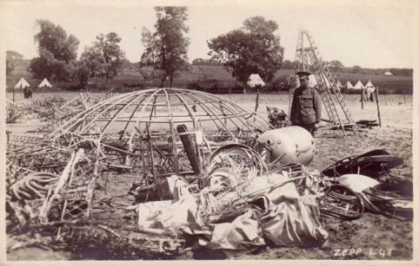

Guarding the wreckage of L48...from T.P.

November 2009 [below]

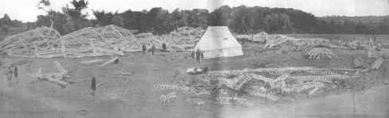

A panorama of the crash site of L48,,,from Tony Preston

December 2009

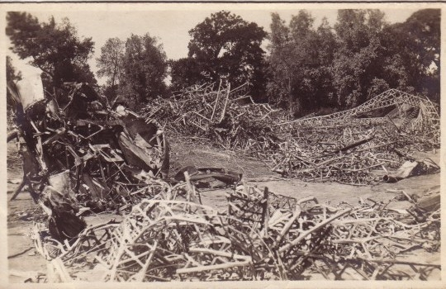

A Canadian photo of the Crash site of L48..from Tony Preston

January 2010 [below]

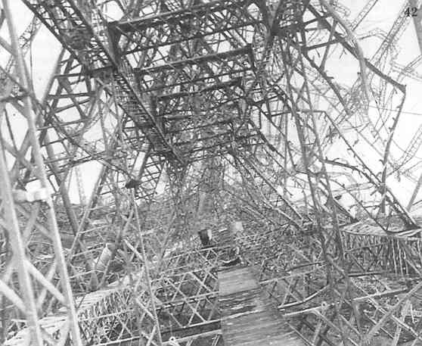

A view through L48 from Ray Rimmell’s book

February 2010
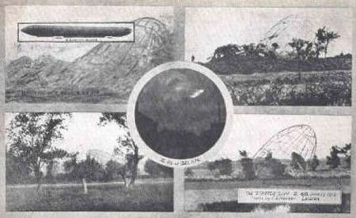

Waddell’s Multi-view card of the L48…..Tony Preston

