Z2 photos of Zeppelin L48

February 2009

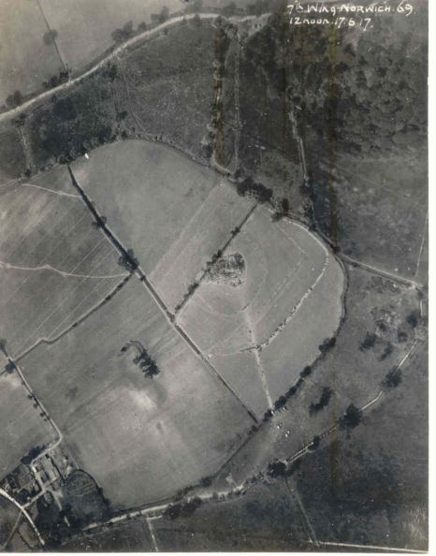
An aerial photo obtained by Tony Preston from Canada which enables the crash site of the L48 to be identified precisely with reference to the buildings and tracks.

[see also below]

February 2009 photo 2

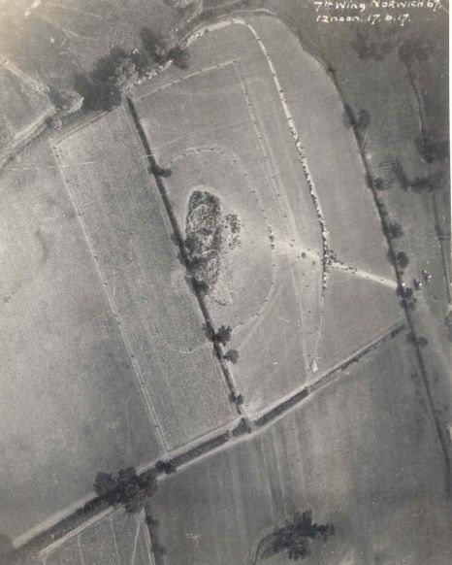
Another shot from lower down shows hundreds of spectators at the
perimeter fence ..a large sum was raised by contributions for the hospital

March 2009

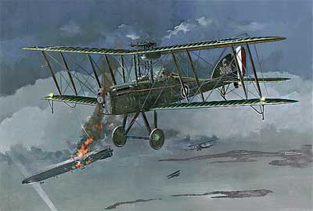

The hunters and their victim

April 2009

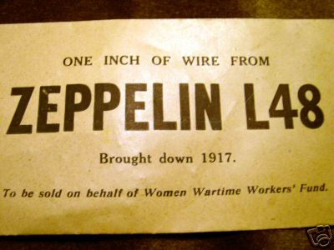

From Tony Preston’s collection.One of many different souvenirs sold in aid of various charities.

May 2009 [below]
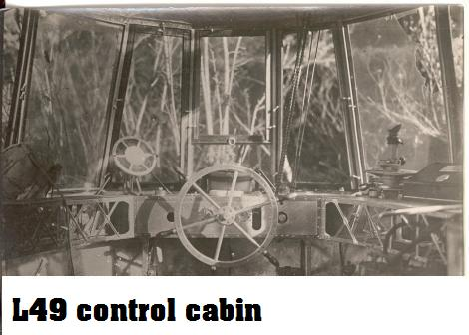
L48’s twin sister which crashelanded in France just
4months after L48 was downed.Parts were displayed in Paris, giving us an idea of what L48 really looked like. From T.P.

June 2009 [below]
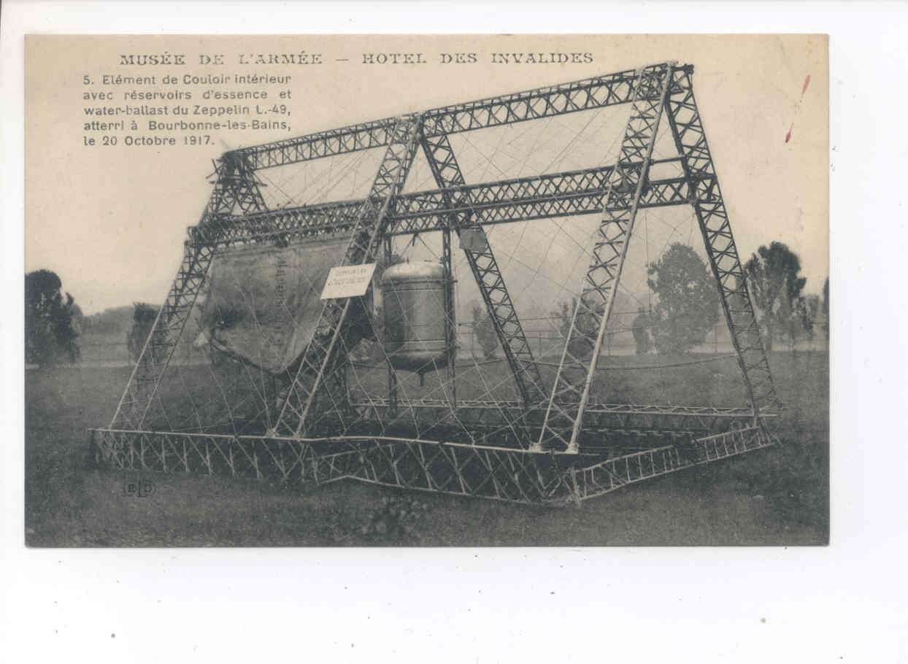
Inside L49..fuel cells & watertanks..identical to L48

