PAST ZEPPELIN L48 PHOTO OF THE MONTH

ZEPPELIN L48 PHOTO OF THE MONTH
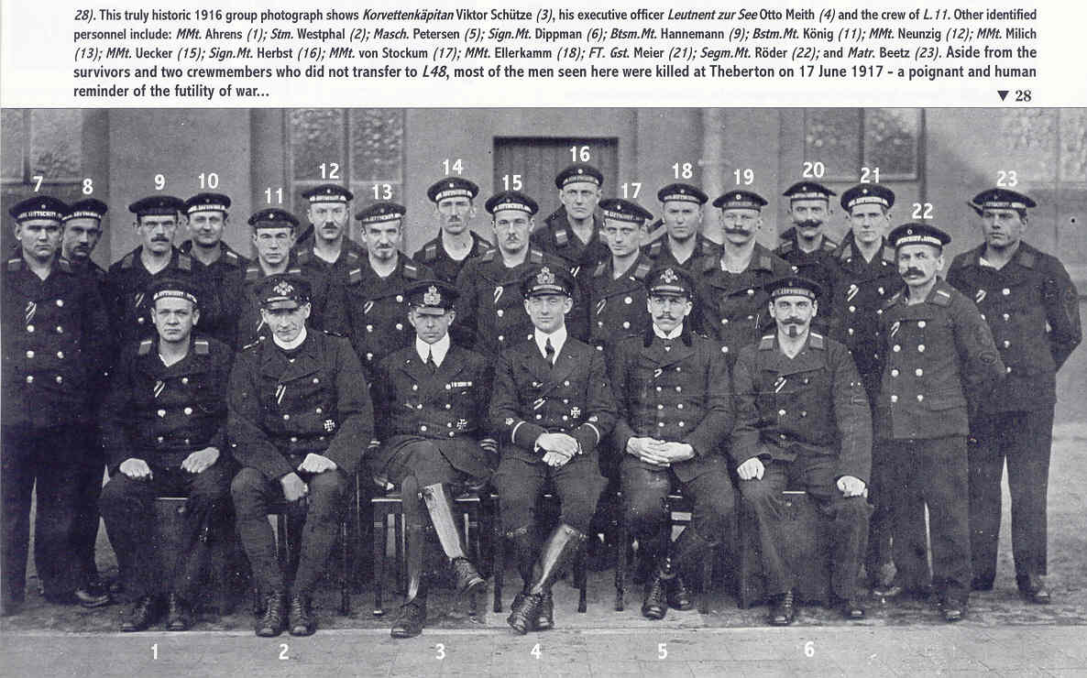
The doomed crew of L48..only No.4 Otto Meith and No.18 Heinrich Ellerkamm eventually survived.
^From Ray Rimmell's "Last Flight of the L48"

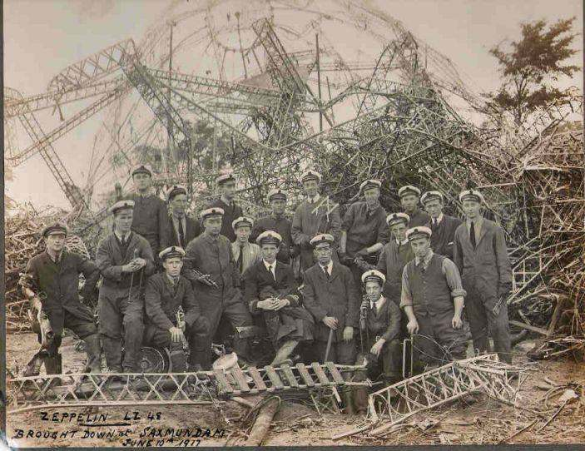

Another crew..the naval crew who salvaged L48……from Tony Preston. May 2008

June 2008
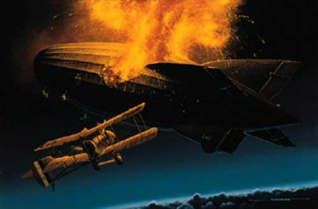
The Death of L48 over Theberton….T.P.

July 2008
L 48 takes off…courtesy Ray Rimmell

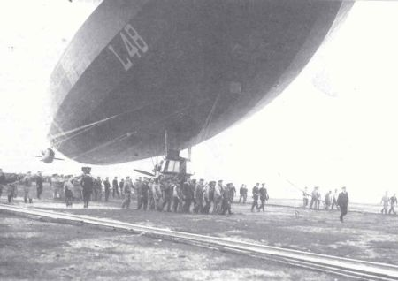
Below…August 2008 from Tony Preston
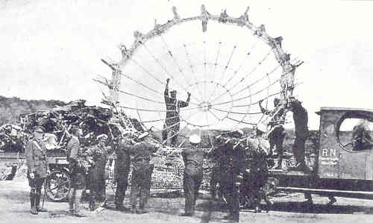

The nose-cone of L48 is placed in a lorry for Leiston Station

September 2008

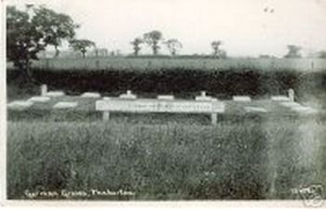

The original graves in Theberton Cemetery…T.P

October 2008

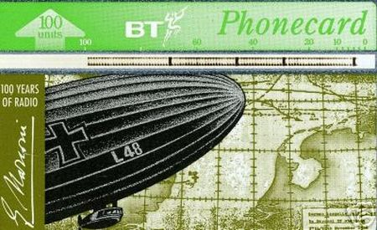

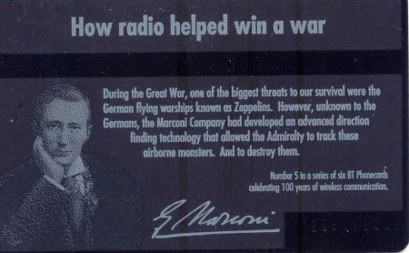

Phone Card about L48 from Tony Preston

November 2008

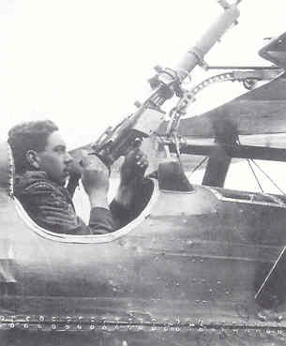

Gunner Sgt. Sid Ashby M.M. who probably did most to shoot down L48
[Courtesy Ray Rimmell from his excellent book "The Last Flight of the L48"]

December 2008

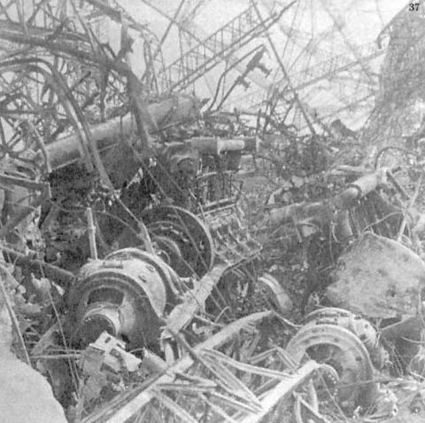

The mighty Maybach Engines of the L48. From Ray Rimmell’s book

January 2009 [below]

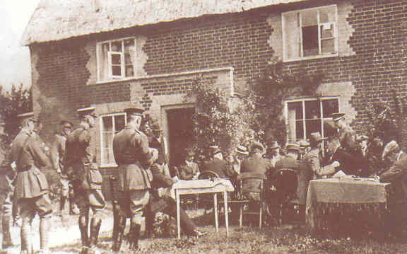

The inquest on the dead crewmen from L48 at Holly Tree Farmhouse. T.P.

