"Unlucky 13"... The 8,641 ton freighter S.S. Magdapur sank on Sep. 10th 1939
at 5.25p.m., just one week after war was declared.
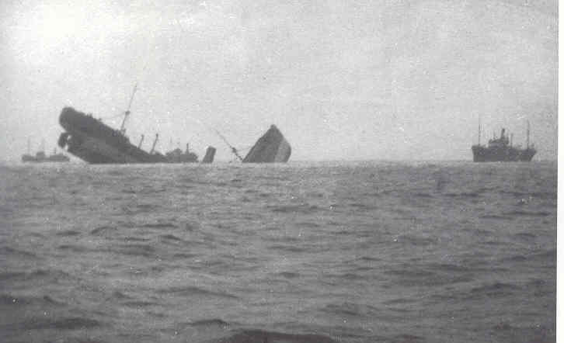 SS Magdapur mined off Sizewell
[NOTE: this one photo has produced an avalanche of requests for more details,my inbox is full! I have now added ALL the extra photos and details that I have.Requested additions are in RED.After 2 or 3 months I will archive all this with the title Sinking of S.S. Magdapur off Sizewell ]
She was the first English ship to be sunk in the war blown in half by a mine laid by the submarine U13 just off Sizewell.[1 of of a string of 9 mines laid on
Sep. 4th, just hours after war was declared, and which claimed the City of Paris
[below]
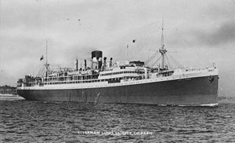
damaged on Sep.16th and the Phryne [below]
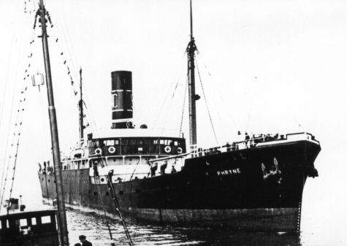
sunk on Sep. 24th..3.5miles E of Aldeburgh Light Vessel]
********************************
S.S. Magdapur
Built in 1920 by Lithgows of Glasgow, this ship was on her way from South Shields to Southhampton , in ballast, when she struck the mine laid by
Capt. Karl Daublebsky von Eichhain's U13. Six seamen were killed,75 were saved by the Aldeburgh lifeboat. It took two and half hours to scrub the blood and oil from the lifeboat "Abdy Beauclerk" afterwards.
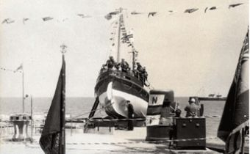

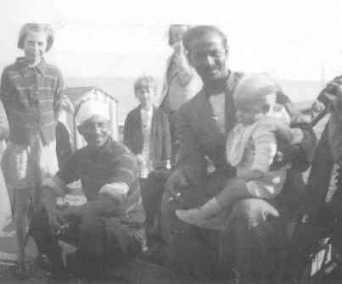
Lascar seamen in Aldeburgh from S.S.Magdapur
To see her now look at 52 15.463 degrees N.,
01 46.624 degrees E (in 2 halves). Ironically the U13 lies a few miles North(52.26 N. 02.02. E) 11 miles SE of Lowestoft.

U13 on the bottom
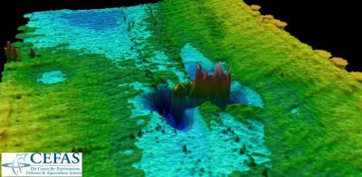
[ Thanks to CEFAS]
……………….Depth-charged by the sloop HMS Weston (below)
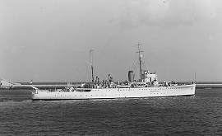
HMS.Sloop Weston

The only U-boat sunk with no loss of life, just 8 months later on 31st.May 1940.(All 26 crew saved) She is intact , upright at 45 degrees,hatch open in 28m. of water.
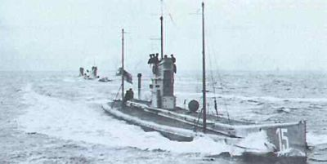
U-13 behind her sisters U-14 & U-15
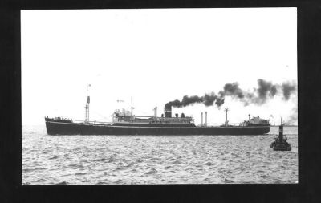
S.S.Magdapur of the Brocklebank Line.
Her captain was Arthur Dixon
(From Tony Preston,Theberton, January 2008)
[who has NO MORE information on this!]
**********************

