HISTORY PAST PHOTOS PAGE 9

October 2010

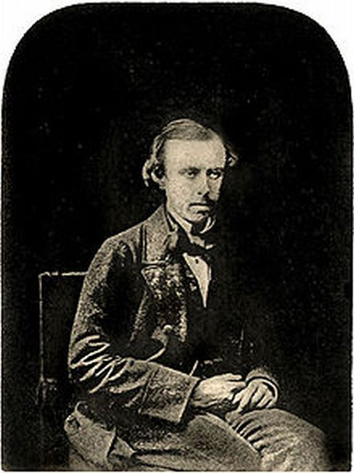

Robert Howlett pioneer photographer
and below his iconic photo of
Isembard Kingdom Brunel

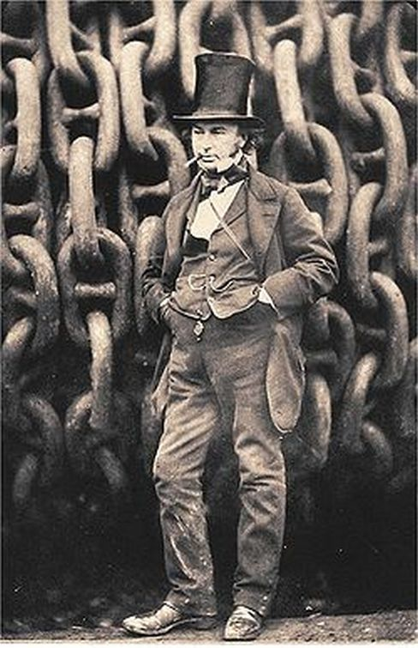

November 2010

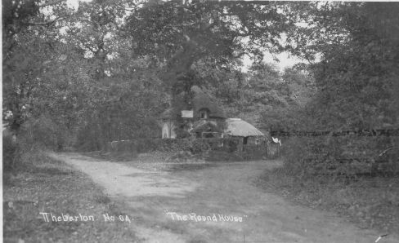

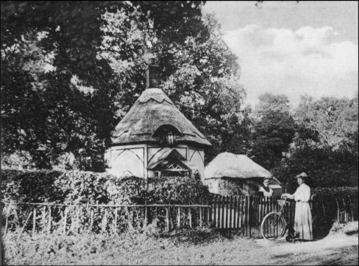
The Roundhouse in Pretty Road
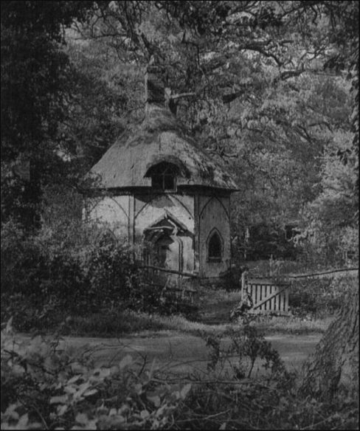

3rd view of the Roundhouse in Pretty Road Theberton…T.P/

December 2010 [below]

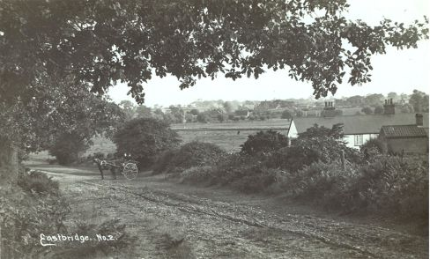

Eastbridge,,,from Tony Preston

January 2011 [below]

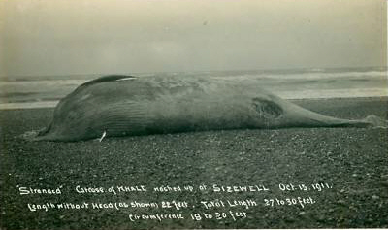

Whale on Sizewell Beach 100 years ago…frpm T.Preston

Feb 2011 [below]

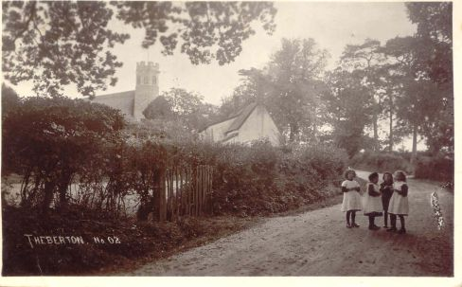

Theberton girls near Church Corner..postmark 1914…T.P.

Please does anyone know who they are…ask your gran !

March 2011 [below]

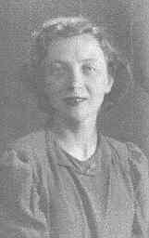

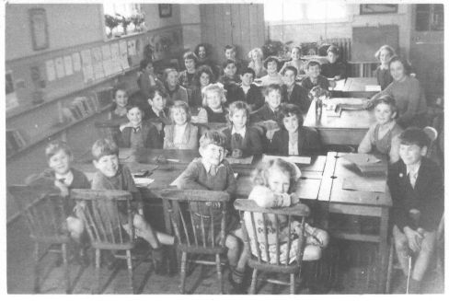
Mary Baptie and her class in the 1950s in the Jubilee Hall
..please send in any names!

