OLD PHOTOS PAGE 8

March 2010 [below]

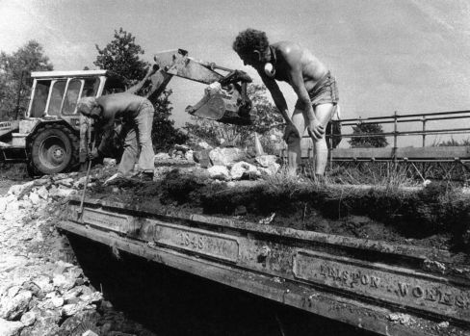

The girder on the Eastbridge dam bridge. From Tony Preston
April 2010 [below]
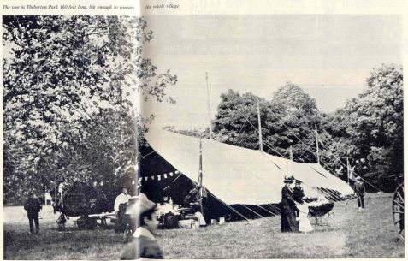

The 160foot tent in Theberton Park..article by Jobson from T.P.

May 2010

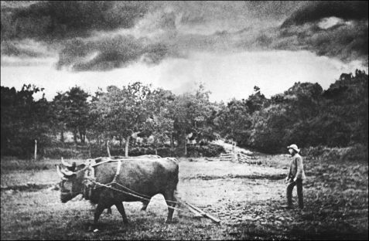

Ox-ploughing at Theberton 1885. From Tony Preston.

June 2010 [below]

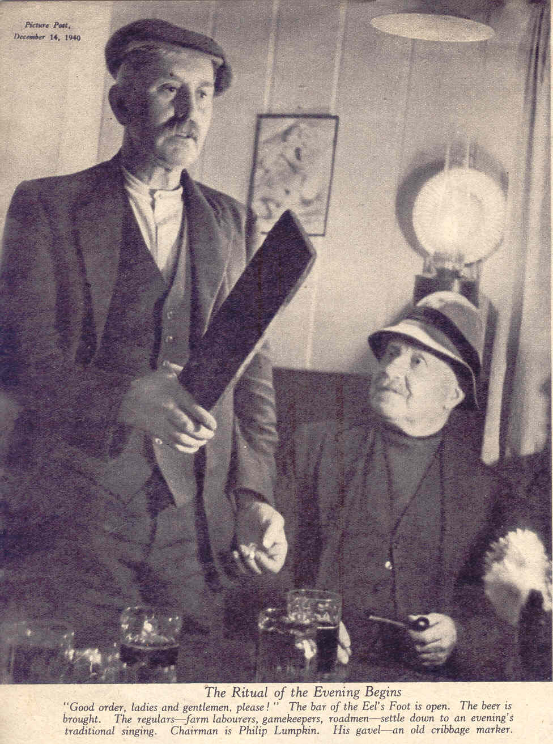
Squit night at the Eel’s Foot 1940

July 2010

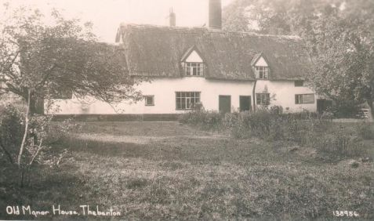

The Old Manor House Theberton…from Tony Preston

August 2010 [below]

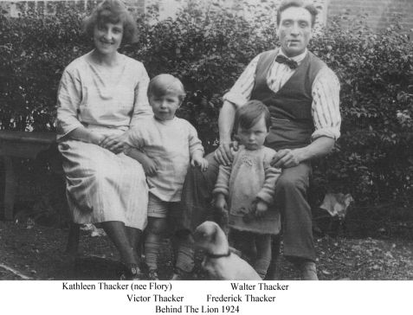

September 2010
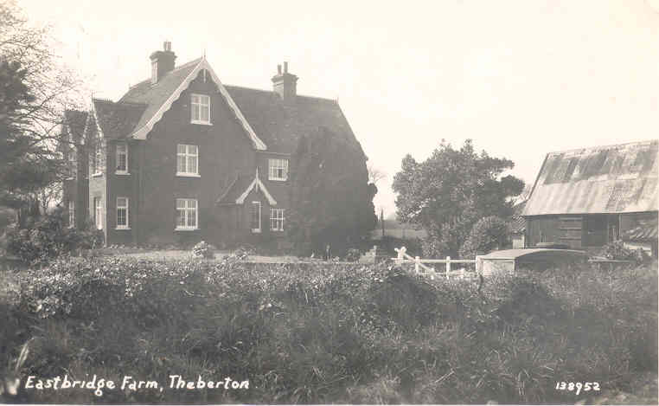

Eastbridge Farm in a 1951 postcard…from T.P.

