OLD PHOTOS PAGE 7

November 2009 [below]

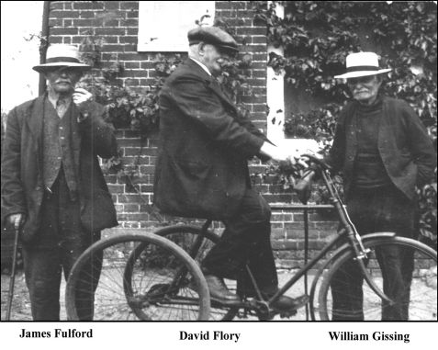

Three fine local gentlemen……T.Preston

December 2009

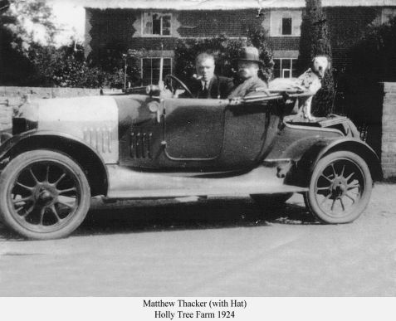

M. Thacker Holly Tree Farm 1924

January 2010 [below[

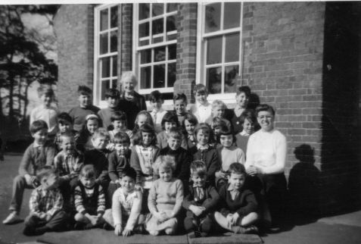

Theberton School from T.P….any names or year?

February 2010 [ below ]
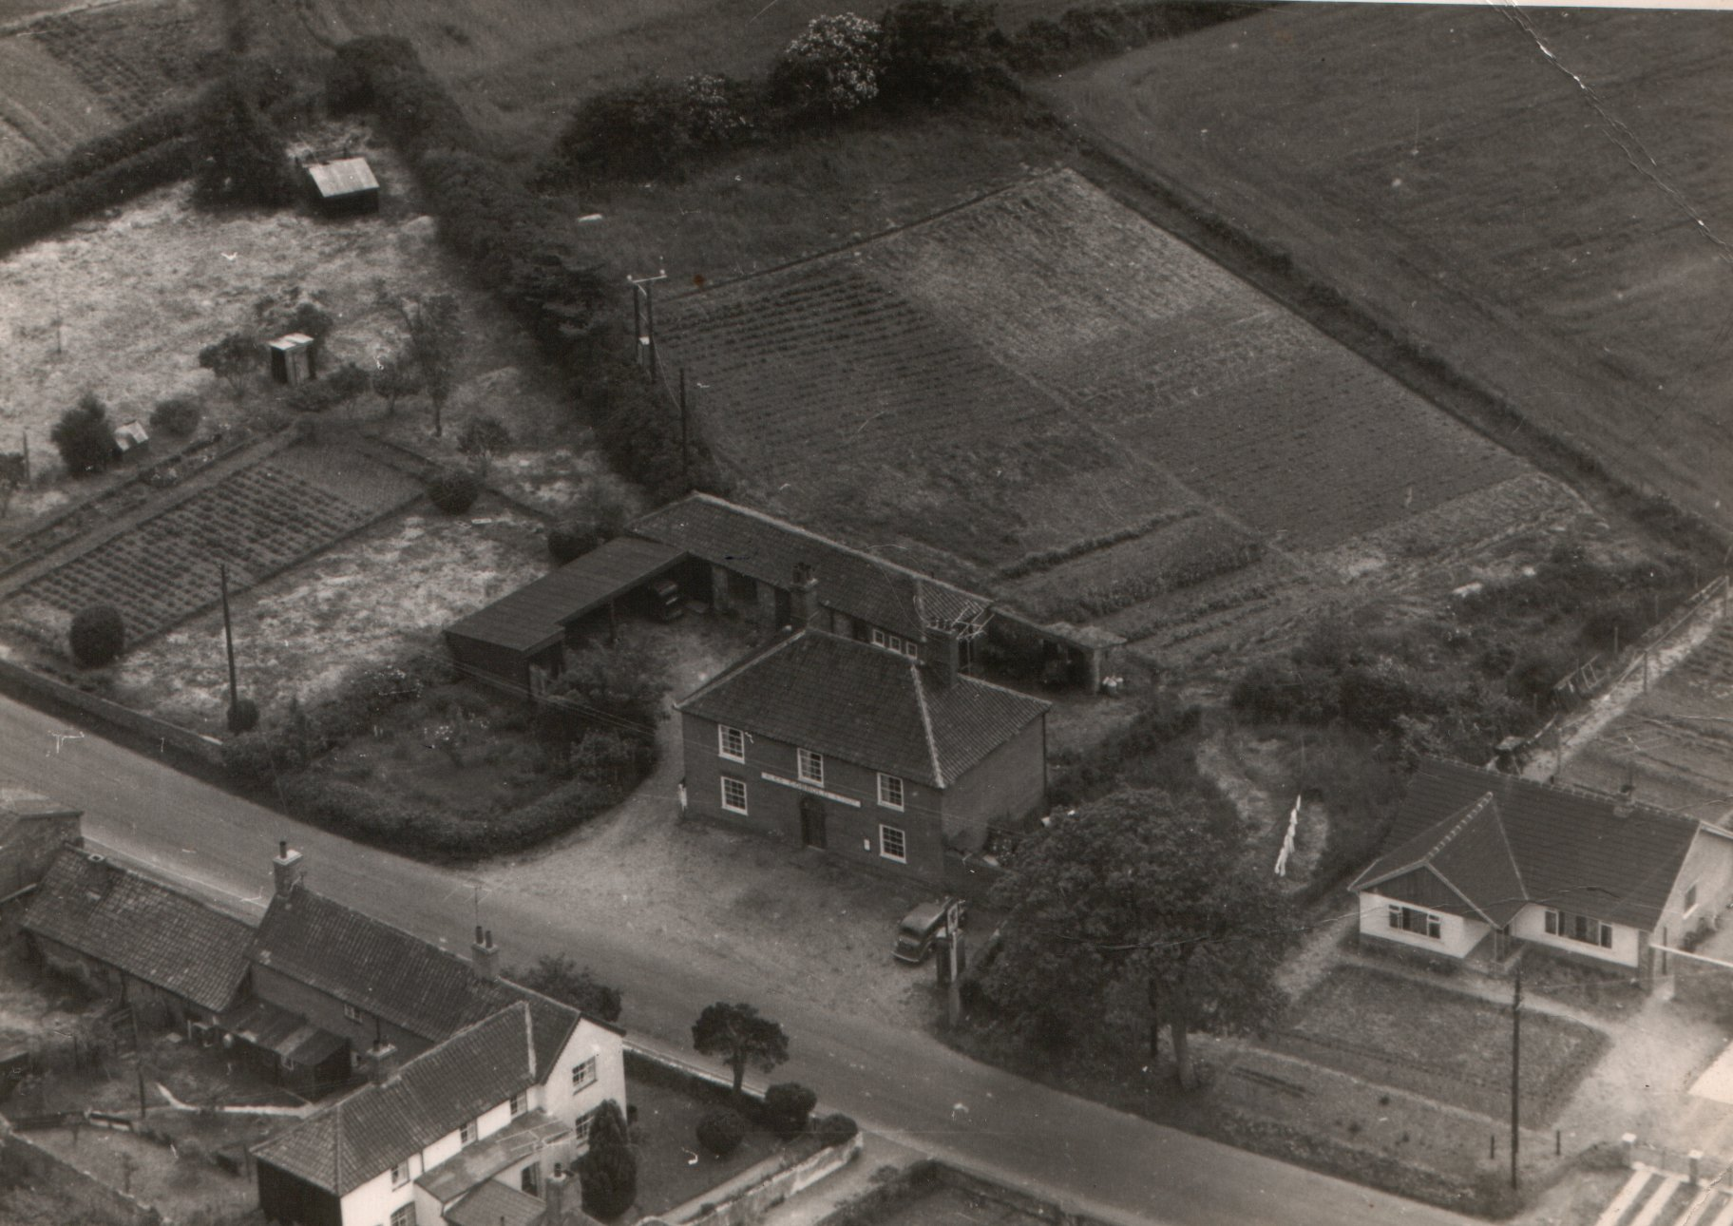

The Lion Inn Theberton [when?]……from Tony Preston

