Local History Photos [Part 6]

July 2009

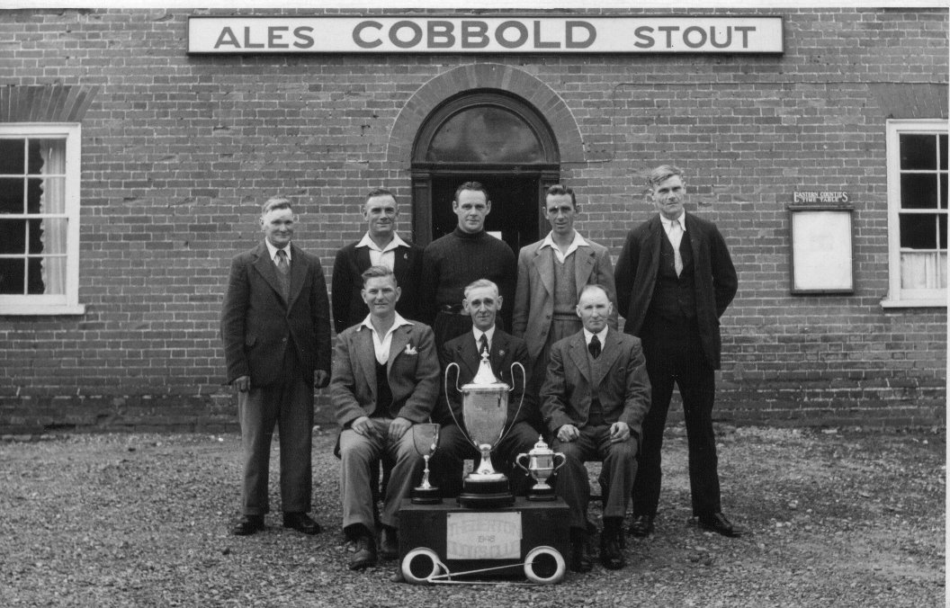

Theberton Lion Quoits Team. From Tony Preston.
{What year?…and who are they?}

August 2009 [below]
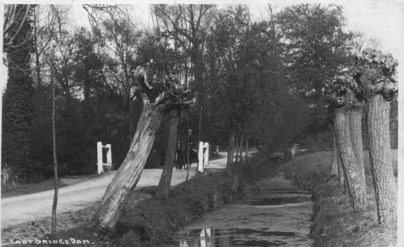

Eastbridge Dam……..from Tony Preston

September 2009[below]

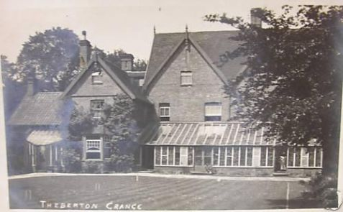

Theberton Grange…………………from Tony Preston

October 2009 [below]

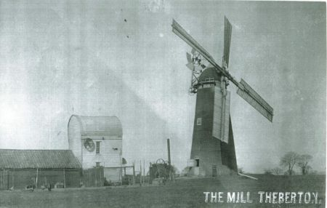

I have had many requests about Theberton Mill..this is the only
other photo that I have................................Tony Preston

