Theberton & Eastbridge P.C. website History 5

September 2008

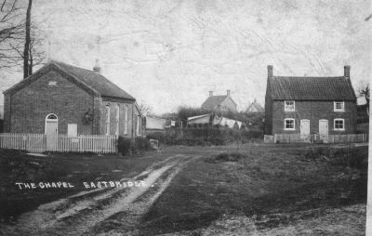

Eastbridge Chapel……from Tony Preston

October 2008

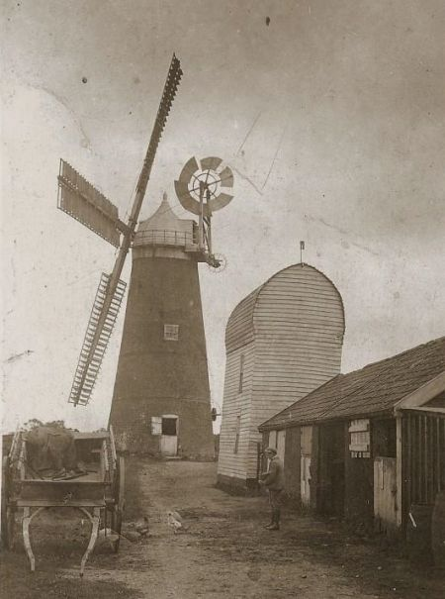

Watson Cole’s Mill Theberton. From Tony Preston

November 2008
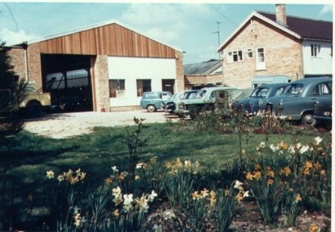

Pat Keeble's Garage..now "Wild About Birds" & Pump Cottages. T.Preston

Dec 2008

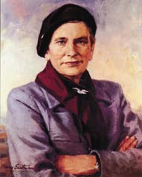

Lady Evelyn Balfour..founder of the Organic Movement T.P.

January 2009 [below]

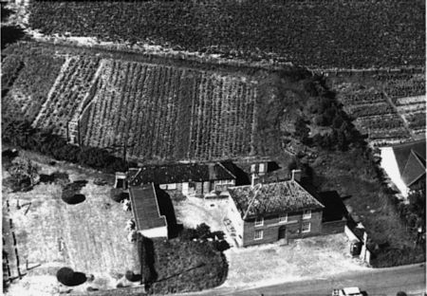

The Lion Inn, Theberton. From Tony Preston
[Any idea of the date?..see car]

February 2009 [ below ]

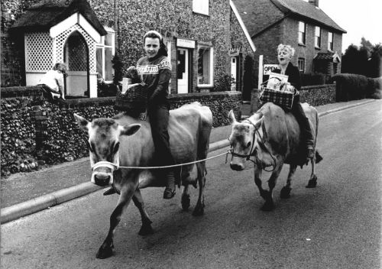

Phil & Heather Baskett 1978 “Magpie” photo Main Road Theberton
Shop/P.O. & Police Station behind [Flint Cottage & Alde House ]

March 2009 [ below ]
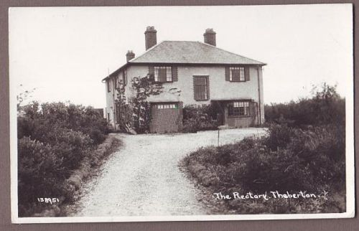

The Rectory Theberton now The Bard’s House from T.P.

April 2009

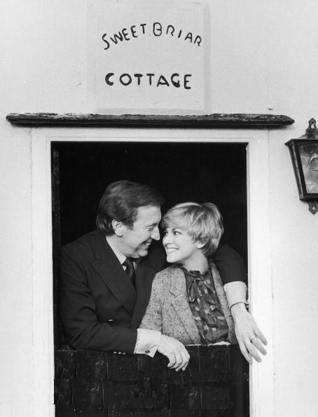

David Frost and Lynn Frederick at Sweetbriar Cottage Eastbridge the morning after their wedding in 1981 in Theberton Church [for which he bought new carpets]

May 2009 [below]
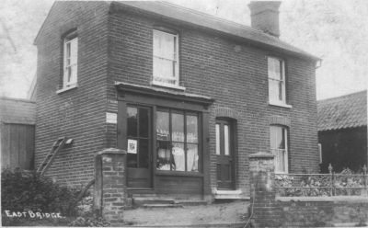

Eastbridge Stores. From Tony Preston.

June 2009 [below]
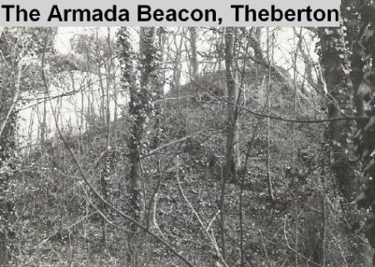
The Armada Beacon mound on the Leiston Road

