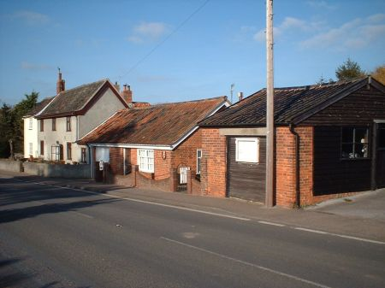
The old Forge now March 2008..sadly just a holiday home.Tony Preston

Eastbridge Then and Now .May 2008
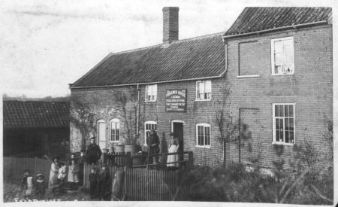
The Eel’s Fott Then [When?] Tony Preston

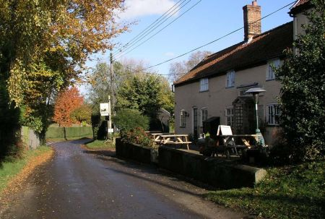
The Eel’s Foot now[May ‘06] Pete Etheridge

June 2008

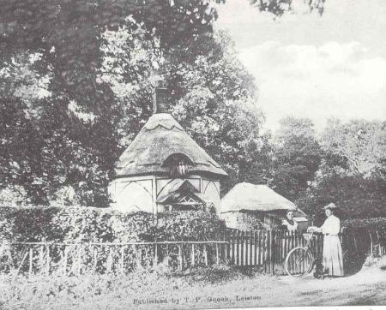

^ The Round House Nuttery Lane..now Pretty Road T.Preston

July 2008

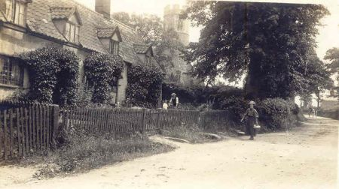

Church cottages Theberton by J Waddell
From Tony Preston in memory of Tony Mitchell

August 2008
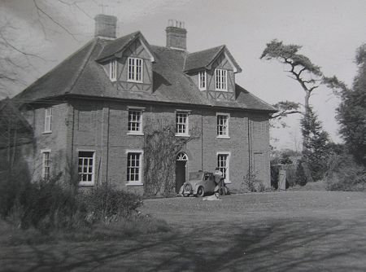

Lower Abbey Farm in the 60s…from Ed

