Past History 2..Working in the forge….Tony Preston
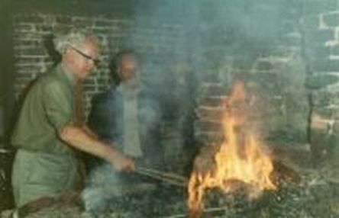
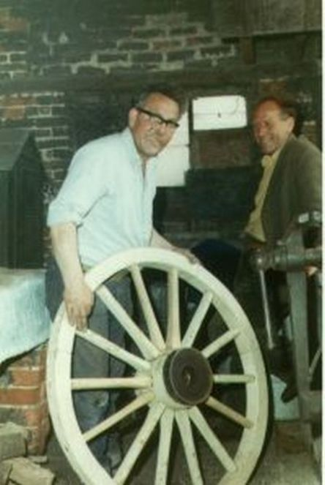
^Keeping the cart rolling……..Tony Preston

