Photos for April 2008
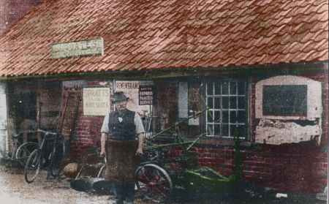
^"Jimmy Coates outside his forge" T.Preston
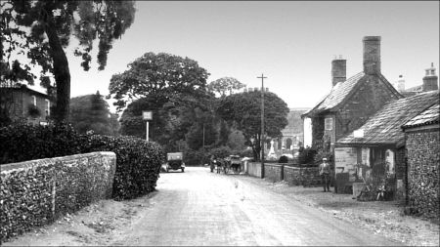
^ The old Forge later……….Tony Preston
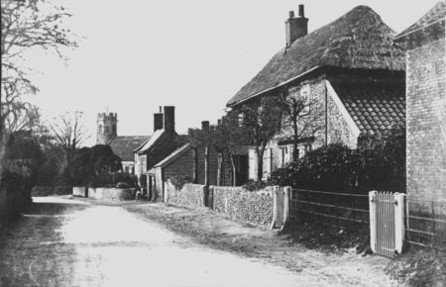
^Alde House,Flint Cottage[P.O.] towards the Forge 1940 T.Preston

