HISTORY PHOTOS PAGE 10

April 2011

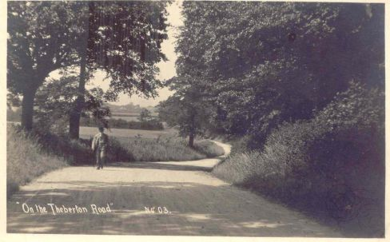

On the road from Theberton…………T. Preston

May 2011 [below]

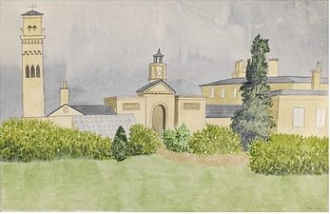

Old painting of Theberton Hall..from Tony Preston

June 2011 [below]

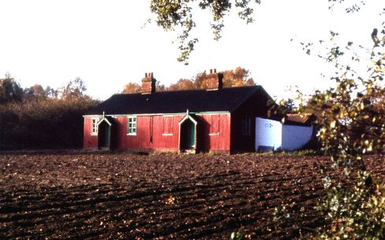

The old Village Hall..now The Granary , Main Road..T.P.

July 2011 [below]
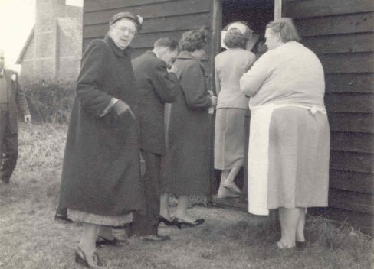

Mary Southgate’s wedding reception March 4th. 1959
Miss Emery left, Mrs Parker right in apron by old village hall .

August 2011

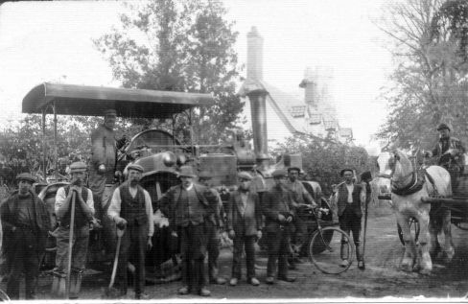

Road gang by Church Cottages Theberton..from Tony Preston
I think this is a Garrett’s roller like Consuela Allen

September 2011

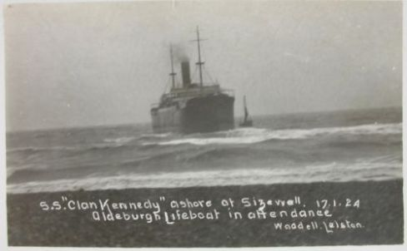

Clan Kennedy aground on Sizewell Banks

October 2011 [below]

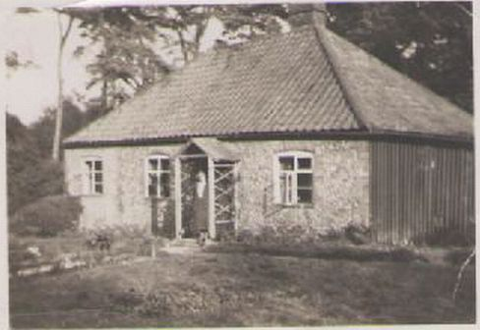

Mary Gower the gamekeeper’s wife for Scott’s Hall Minsmere in 1937..note the tin “wall”.

November 2011 [below]

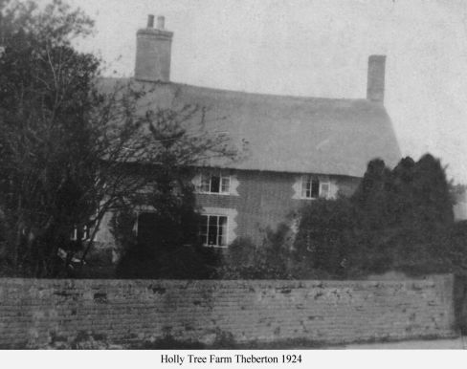
…from T.P.

December 2011

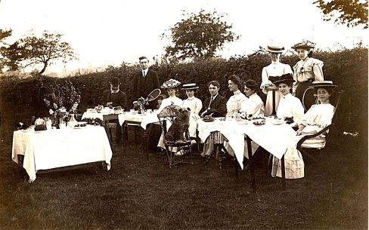

After tennis.Theberton 1911 next to the graveyard…T.P.

