PAST “OLD POSTCARD/PHOTO OF THE MONTH”

DEC 2007
Photo for December 2007
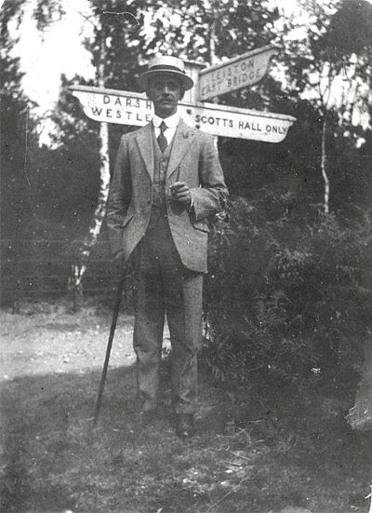
"Charles Morrice near Eastbridge Walks 1921"..
from the collection of the late Chris Morrice.

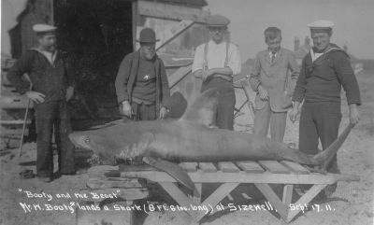
"How about that Noel Cattermole?!!!"
(From Tony Preston,Theberton, December 2007)
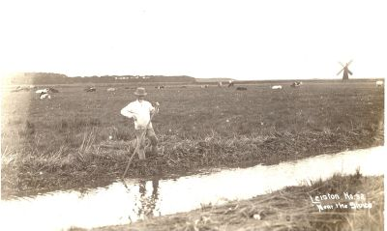
Windpump & Marshes, Eastbridge
Tony Preston Jan 2008

Photo for February 2008
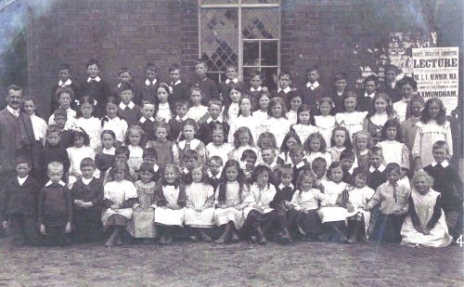
"Theberton School 1912"
From Tony Preston

S.S. Magdapur Mined off Sizewell September 1939
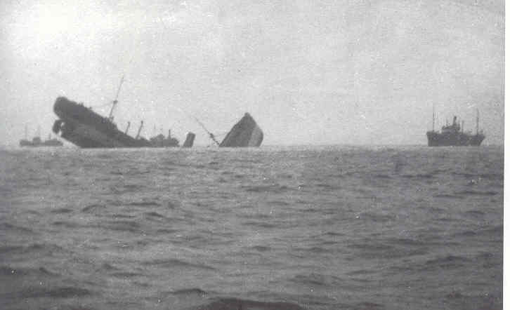
From Tony Preston

Photos for March 2008
Theberton Then and Now
1911 Post Office & Shop..[r.]Police House
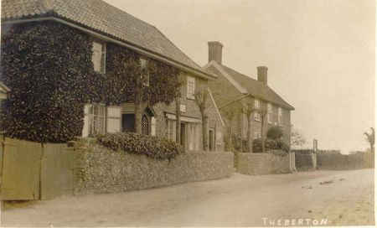
[below] later..P.O.& shop..n.b.village hall r.
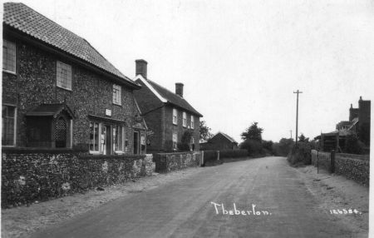
[below] 2008 Flint Cottage & Alde House r.
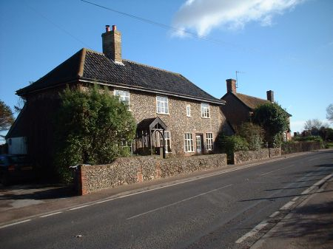
From Tony Preston,Theberton

