Y5 PAGE 5 OF YOXFORD BOYS PHOTOS

NOVEMBER 2011

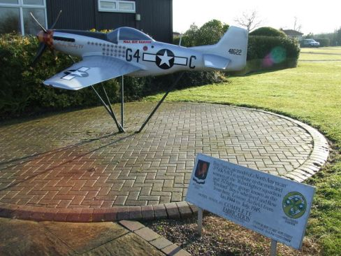

Model of Kit Carson’s Nooky Booky IV at Cakes and Ale………….T.P.

December 2011 [below]

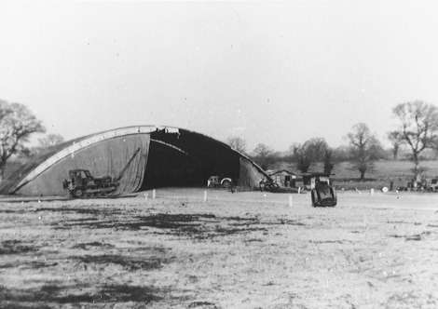

Blister hangar of the 364th…..T.P.

January 2012 [below]

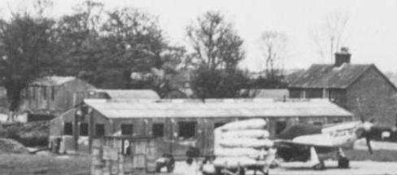

Fuel Tanks….from T.P.

February 2012 [below]

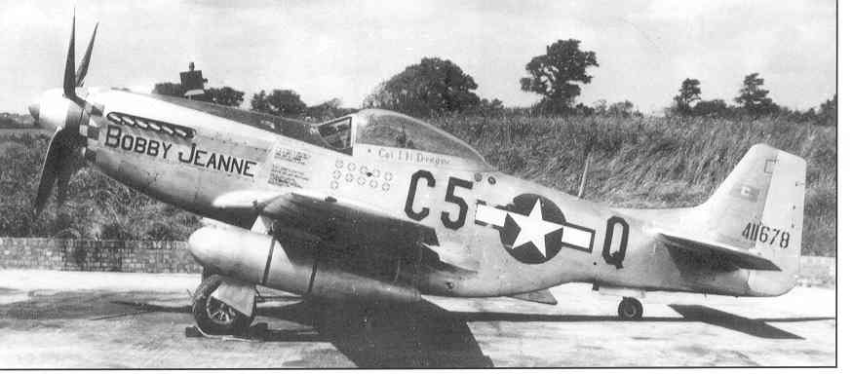

Col Dregne’s Bobby Jeanne…….T.P.

March 2012 [below]

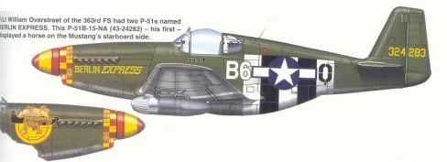

April 2012 {below]

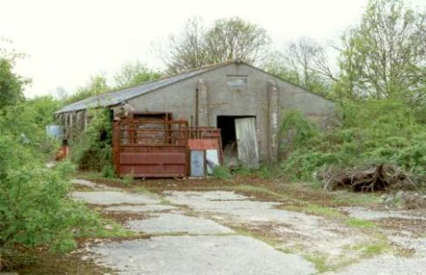
362nd Tech. Area as it is now

May 2012 [below]

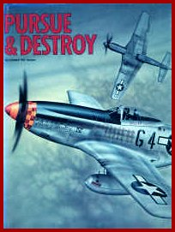

“Kit” Carson’s book

June 2012 [below]

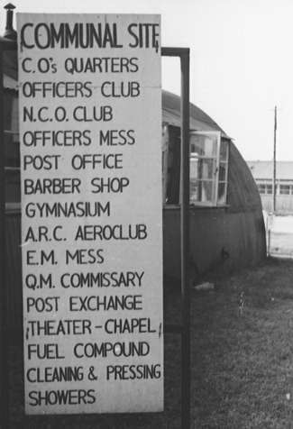

Directions board at Leiston

July2012 [below]

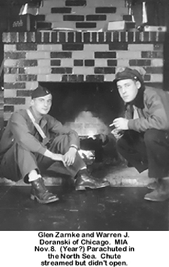

August 2012 [below]

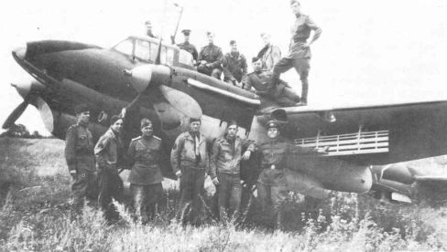

364th ground crew with Russians

