Yoxford Boys Photos sheet 4
July 2010
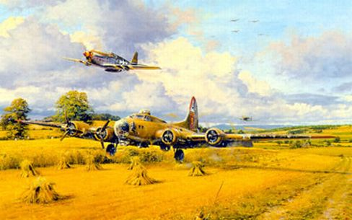

“Out of Fuel”….via T.P.
August 2010 [below]
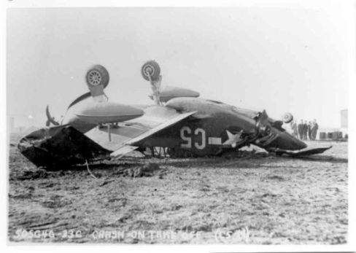

Oops!!!…………………………………from T.P.

September 2010

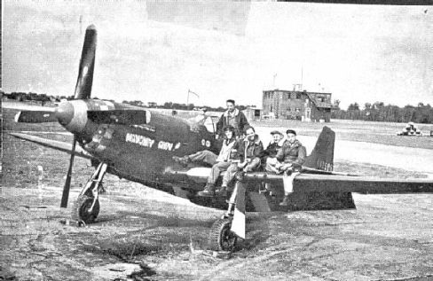

Joe’s Naughty Audi

October 2010 [below]

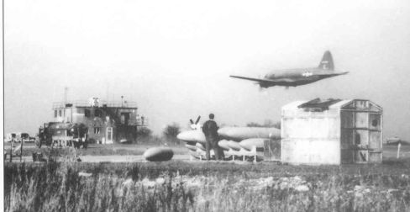

A C-46 buzzes the control tower at Leiston..T.P.

November 2010

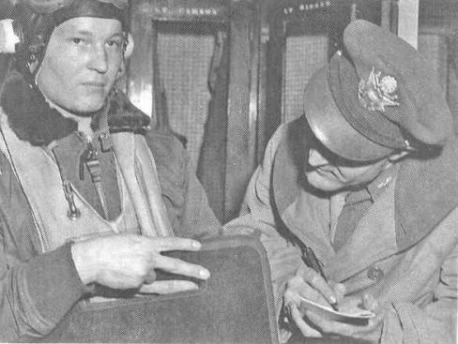

Fletcher Adams poses for the camera..he has just shot down
two German fighters. Shortly he will be shot down and then
murdered by German Civilians [read “The Bleeding Sky”]

December 2010 [below]

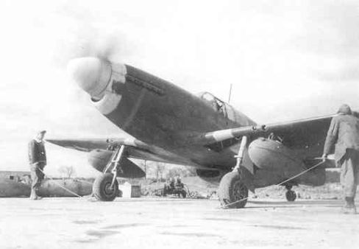

First Mission from Leiston 11-02-1944 ….from T.P.

January 2011 [below]

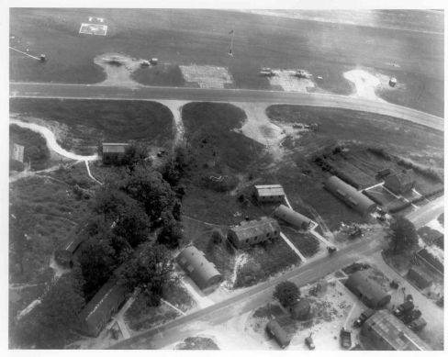
362nd tech area..Harrow Lane bottom right…T.P.

Feb 2011

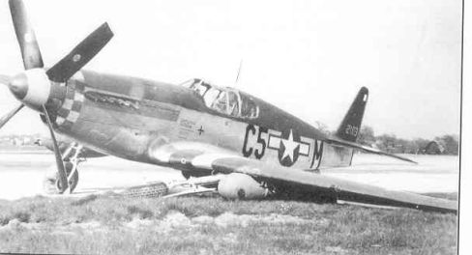

C5 – M after a ground loop at Leiston……T.P.

March 2011 [below]

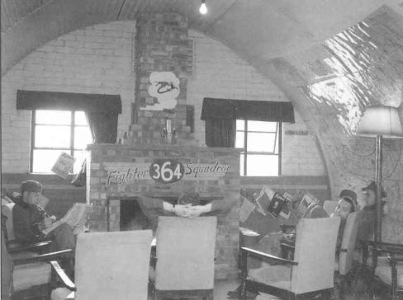

364th Pilots’ Room………..from Tony Preston

April 2011

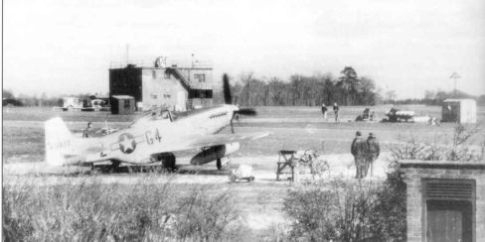

Panorama with control tower and BZ-4…..T.P

May 2011 [below]

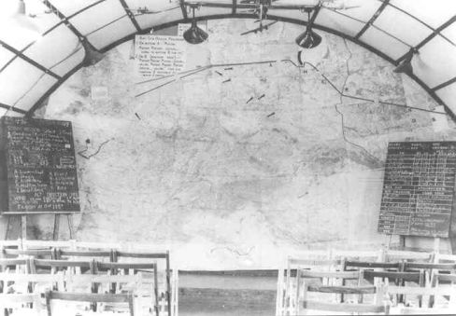

Map for Operation Frantic 06.08.44….T.P.

June 2011 [below]

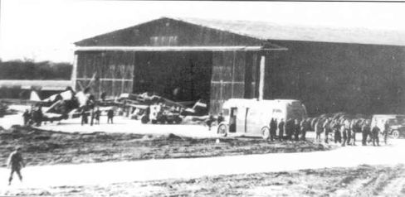

Doughnut wagon by the 469th maintenance hangar

July 2011 [below]

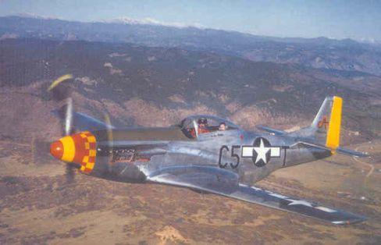

“Mormon Mustang”

August 2011 [below]

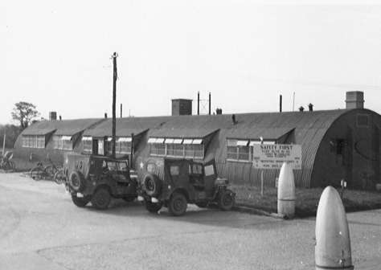

Jeeps by the communal site of the 357th.

September 2011

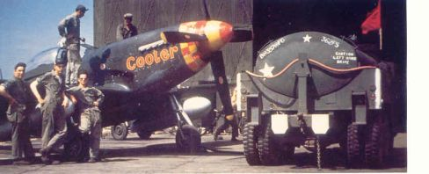

“Cooter” with petrol bowser

October 2011

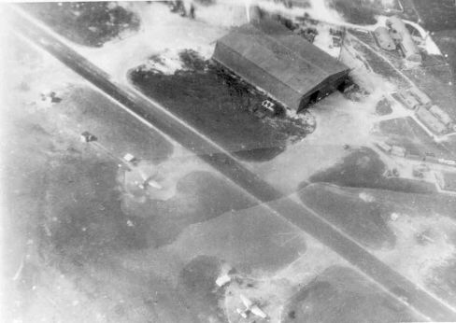

Aerial view of 469th Maintainance hangar Leiston….T.P.

