OLD YOXFORD BOYS PHOTOS page 3

August 2009 [below]

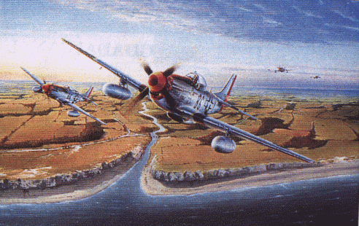

Low level attack by the 357th…via T.P.

September 2009 [below]

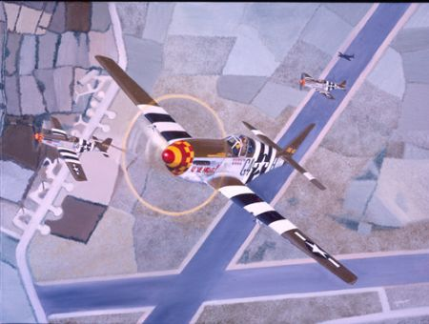

D-Day return……….from T.P.

October 2009[below]

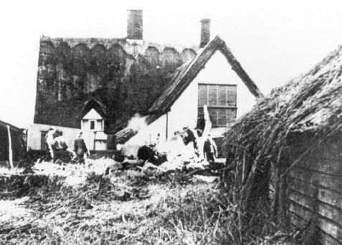

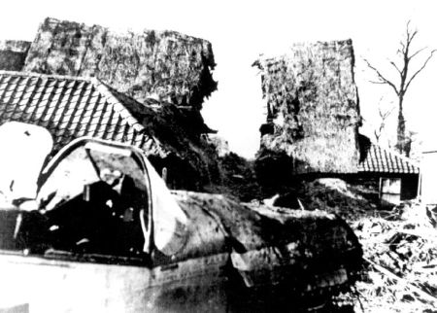

Billy Jo crashes into the farmhouse roof...pilot safe! T.P.

November 2009 [below]

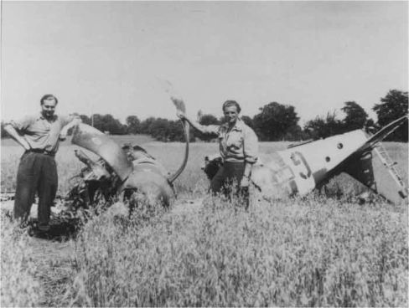

G4G after a rough landing….from Tony Preston

December 2009

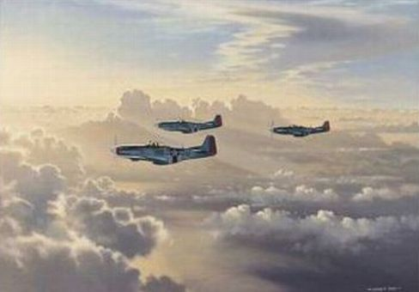

Homeward Bound….from Tony Preston

January 2010 [below]

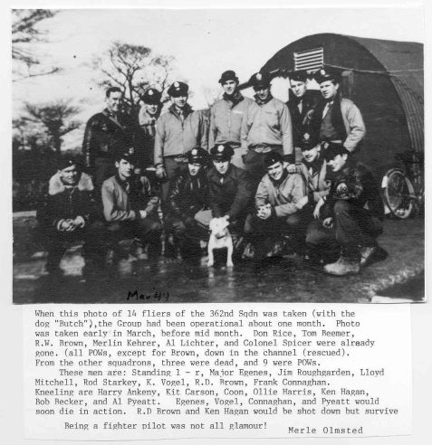

362 message from Merle Olmsted…via T.P.

February 2010 [below]

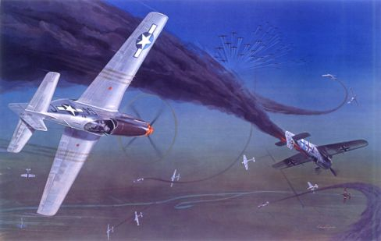

357th Dogfight…frm Tony Preston.

March 2010 [below]
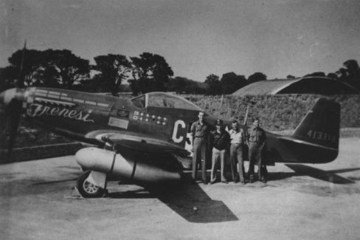
Frenesi…from Tony Preston

April 2010

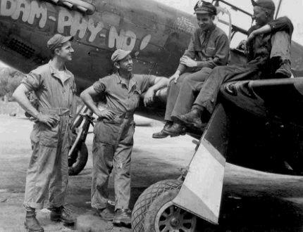

Fisher’s Dam-Phy-No……..T.P.

May 2010 [below]

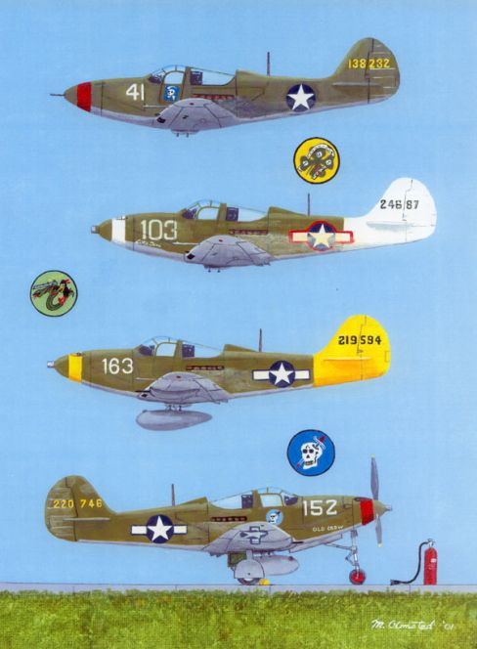

Silhouettes of some 357th. planes. T.P.

June 2010 [below]

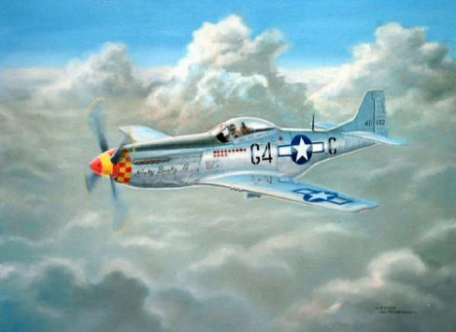

Nooky Booky 2….from T.P.

