Y2 photos of the Yoxford Boys

February 2009

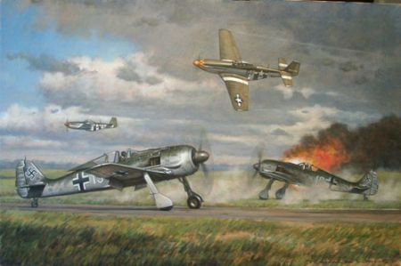

Ground attack by the 357th. via Tony Preston

March 2009 [below ]

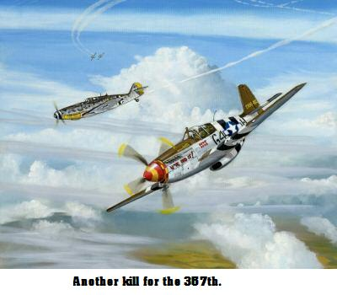

April 2009

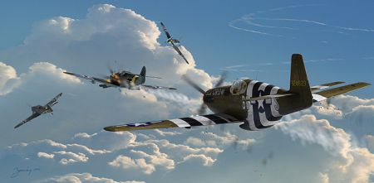

Dogfight over Germany. From Tony Preston

May 2009 [below]

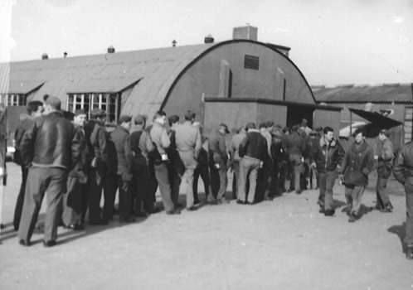
The 357th. mess-hall. From Tony Preston

June 2009 [below]
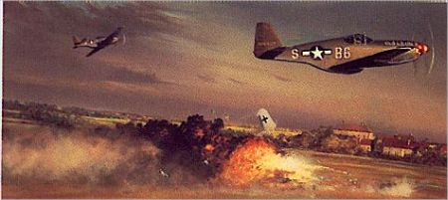

The older Mustangs in action. via T.P.

July 2009 {below}

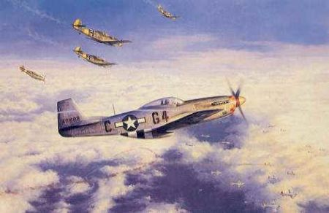

“Hot Pusuit” via T.P.

