PAST “YOXFORD BOYS” PHOTO OF THE MONTH
April 2008
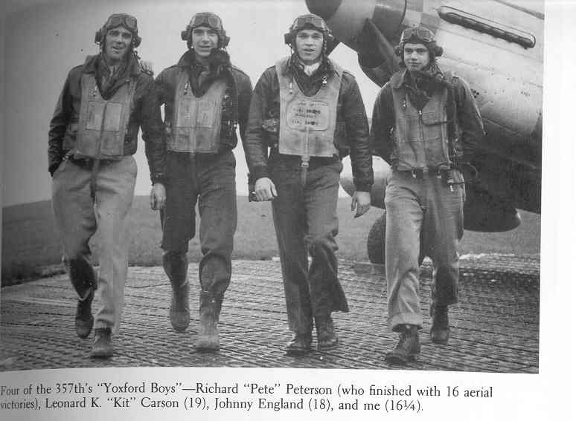
The “me” is Clarence “Bud” Anderson

May 2008
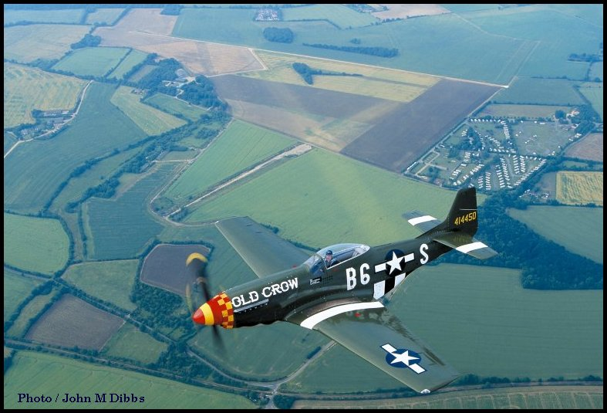
Cakes and Ale..runways visible in crop marks.

June 2008
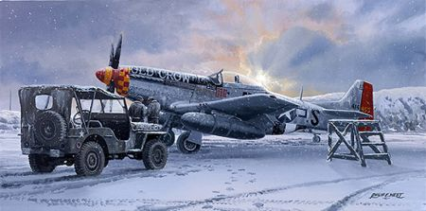
The Winter of ‘45

July 2008

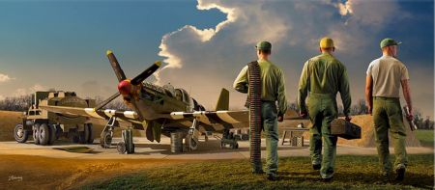
Time to go to work

August 2008

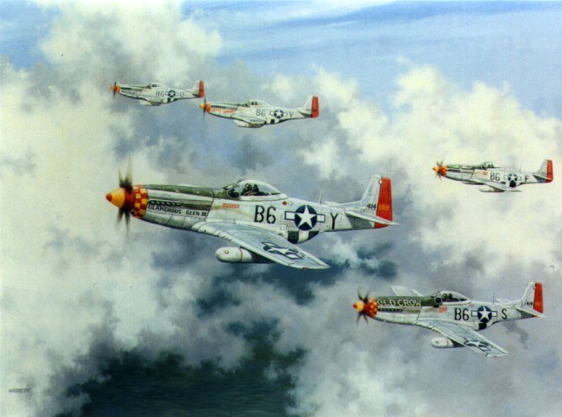
“The Leiston Boys” by Barry Weekely

September 2008
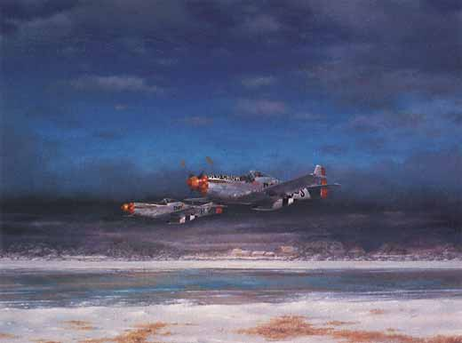
“Return to Leiston”

October 2008

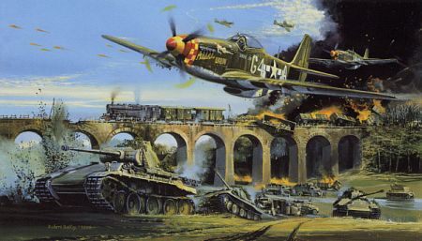

357th. Mustangs Strafing in Europe

November 2008-11-20
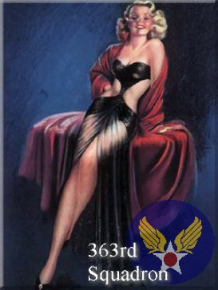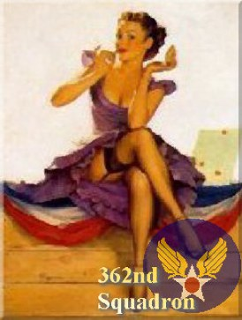

Two unofficial Squadron Badges of the 357th...via Tony Preston

December 2008

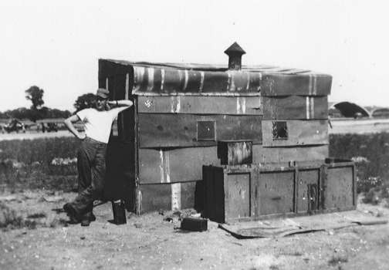

A line-hut made from ammunition boxes at Leiston Airfield. T.P.

January 2009 [below]
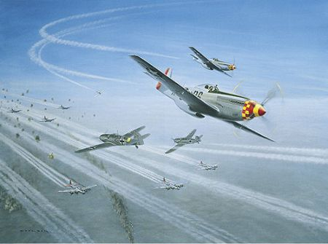
“Top Cover” via Tony Preston

